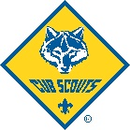
Membership Cost & Fundraising
Cub Scout Membership includes National/Council fees that are paid when you register online, and Pack dues (paid in person to “Pack 482”). When you register online, that is for your child’s National/Council registration and is good for one year. Pack 482 has annual dues of $180, which is the all-in cost for a year of scouting (not including our campouts or summer camp). We break Pack dues up into 3 payments collected by the 15th of Sept, Nov, and Jan. Our campout fee is structured $30 for each campout (4 total are planned). You can pay these completely out of pocket or choose to participate in pack fundraisers. Our goal is to make scouting accessible to every family.
Pack Dues cover: Initial pack T-shirt, all awards, belt loops, ranks, A.O.L. arrows, pinewood derby kit, den meeting, supplies, awards ceremonies, holiday parties, and registration and training for our volunteer den leaders.
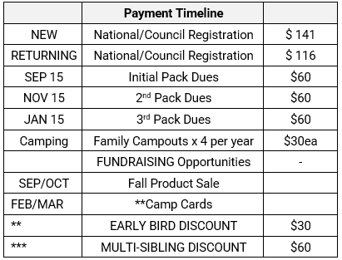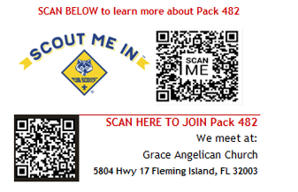
Total Scout Cost (registration, dues, program fee, camping fee) $441.
Fundraising
Pack 482 offers several different opportunities throughout the year to fundraise. You can participate in as many fundraisers as you want. Fundraising is not a pack requirement, but it is strongly recommended. It helps not only to fund your Scout’s activities, but also gives them an opportunity to interact with the local community as well as learn good sales etiquette.


Fundraisers for Pack 482
Popcorn –End of summer/Early Fall
Camp Cards – Spring
** Early Bird Discount (pay National/Council + Program Fee) On or Before 10/1/23 get $30 off
*** Multi- Sibling Discount (payments made on time with schedule get $60 off one scout.

